History Mystery Challenge
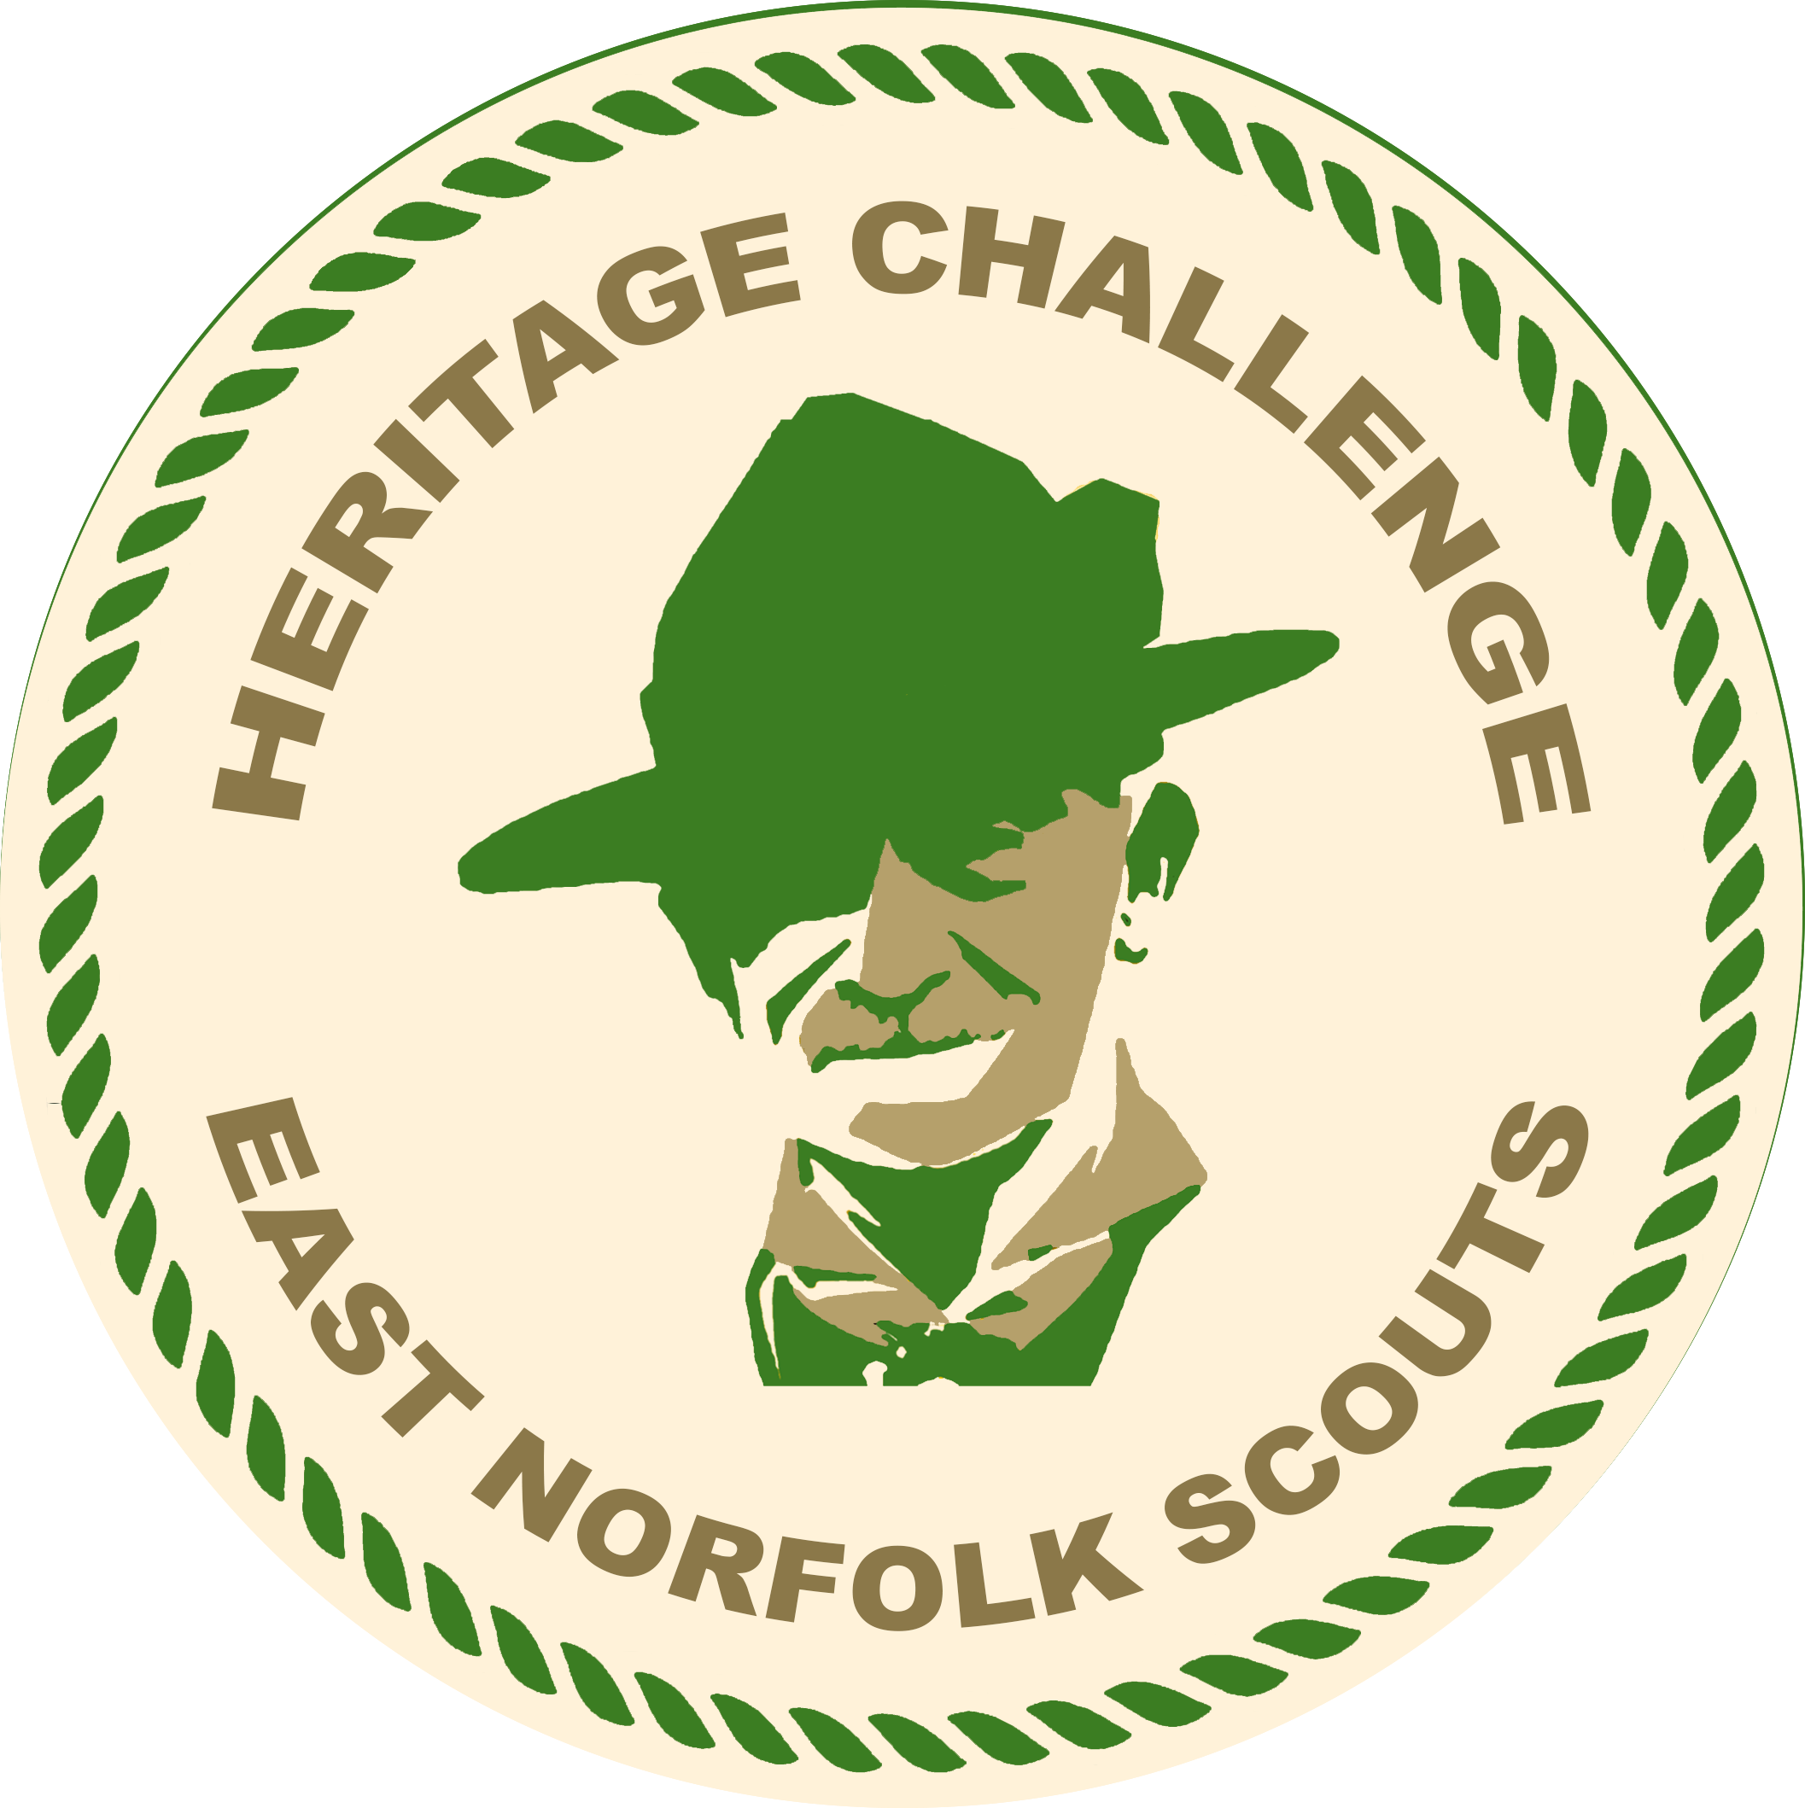

Name:

Scout Group or Unit:

- What year was the first Scout census in Great Yarmouth
- What year did W. H. Back gain his Wood Badge in the early days
- Which District Commissioner was in post in 1977
- Who gifted the Ambulance Trophy
- What year did the woggle become part of the Scout uniform
- What building did 1st Gt. Yarmouth use in 1910
- Who was the Group Scout Master of 3rd Gt. Yarmouth in the 50’s
- What church did 5th Gt. Yarmouth use as an HQ in 1910
- How many Scouts were in 7th Gt. Yarmouth troop in 1928
10. Where did the 9th Great Yarmouth group meet
11. What group did 10th Gt. Yarmouth amalgamate with in 1969
12. What organisation was 12th Gt. Yarmouth associated with in 1925
13. What year did 15th Gt. Yarmouth close
14. Who registered the 20th Gt. Yarmouth group
15. What year did Acle Cubs take part in the National Tea Challenge
16. What colour necker did 1st Belton wear in 1976
17. Russ Abbott was part of 1st Bradwell in which year
18. What year did 1st Burgh St. Peter do the Shredded Wheat Challenge
19. What year did 1st Caister Scouts win the Road Safety competition
20. What year did 1st Cantley become 1st Freethorpe
21. How many years did 2nd Fritton group meet
22. What year did 1st Gorleston Scouts go to Switzerland
23. What anniversary did 2nd Gorleston celebrate in 2019
24. What colour necker did 4th Gorleston group wear
25. Who was the lady Scoutmaster of 1st Ormesby in 1916
26. In what year was 1st Martham dedicated as “Craig’s Own”
27. What year did North Yarmouth open the first district Squirrel Drey
28. Where did 1st Winterton meet in 1923
29. Where did the Rover Crew from 8th Gt. Yarmouth meet
30. What was the name of the first Scout Network in Gt. Yarmouth
31. What year was Janet of the ASU presented the Silver Wolf
32. in 2007 the Sunrise Ceremony took place on what date
33. What year did B.P. sketch “Friends of the World at the Jamboree”
34. Who painted the “Classic Campfire” for the Heritage Project?
Please email your completed History Mystery Challenge Sheet to: heritage@eastnorfolkscouts.org.uk

